**Practical 6**

**Configuring Simple and multi-area OSPF**

**Aim:** Configuring Simple and multi-area OSPF

**Theory:**

Open shortest path first (OSPF) is a link-state routing protocol that is used to find the best path between the source and the destination router using its own shortest path first (SPF) algorithm. A link-state routing protocol is a protocol that uses the concept of triggered updates, i.e., if there is a change observed in the learned routing table then the updates are triggered only, not like the distance-vector routing protocol where the routing table is exchanged at a period of time.

Open shortest path first (OSPF) is developed by Internet Engineering Task Force (IETF) as one of the Interior Gateway Protocol (IGP), i.e., the protocol which aims at moving the packet within a large autonomous system or routing domain.

OSPF advantages –

1. Both IPv4 and IPv6 routed protocols
2. Load balancing with equal-cost routes for the same destination
3. Unlimited hop counts
4. Trigger updates for fast convergence
5. A loop-free topology using SPF algorithm
6. Run-on most routers
7. Classless protocol

There are some disadvantages of OSPF

1. It requires an extra CPU process to run the SPF algorithm
2. Requiring more RAM to store adjacency topology, and
3. Being more complex to set up and hard to troubleshoot

**Part a) Simple OSPF**

We use the following topology for the present case

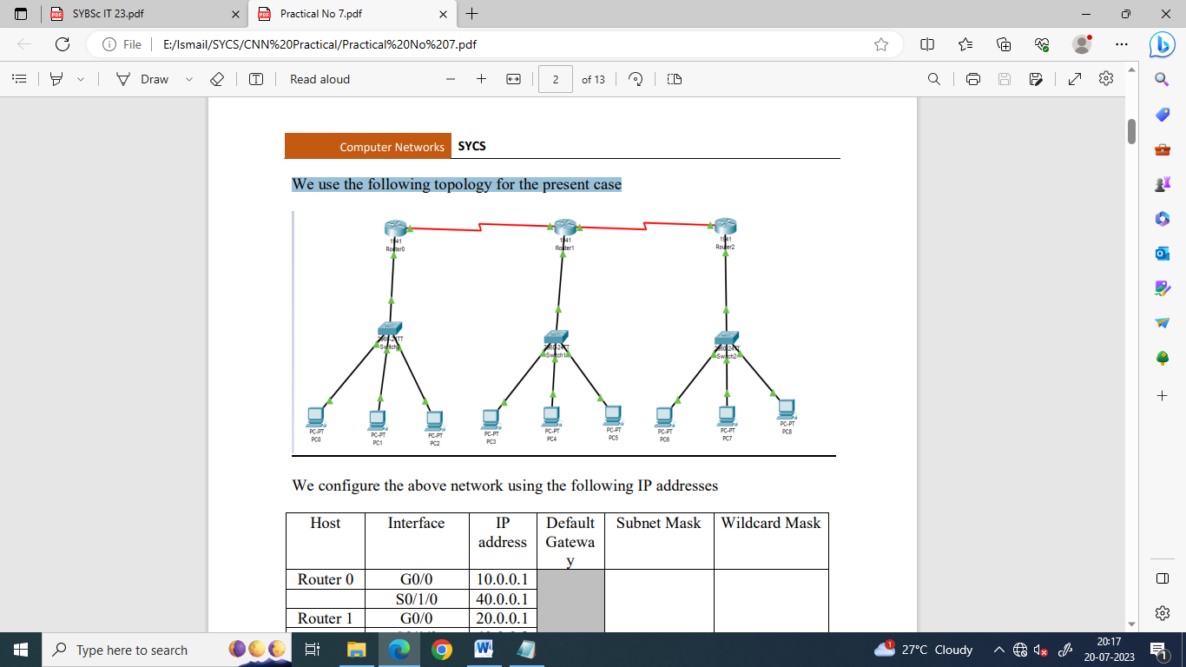

We configure the above network using the following IP addresses

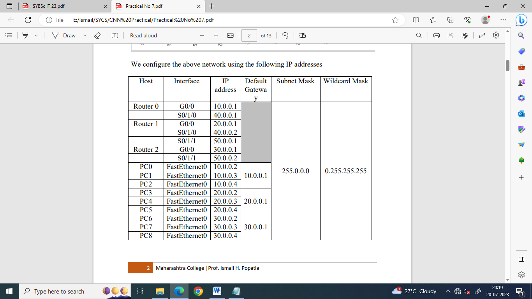

We need to add a Serial Interface in each Router, it is done as follows

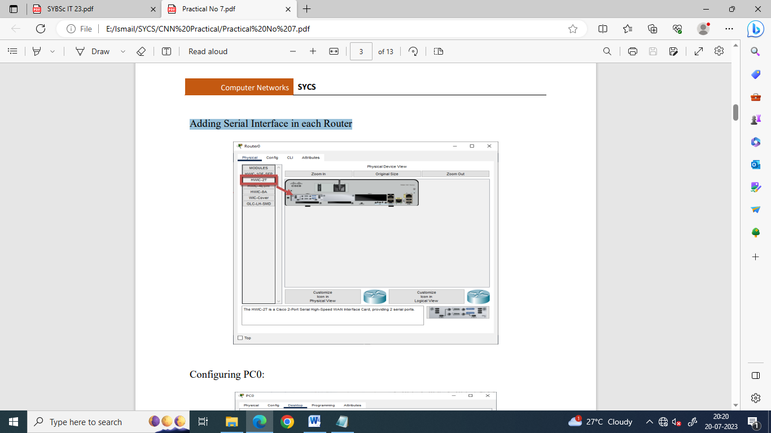

Configuring PC0:

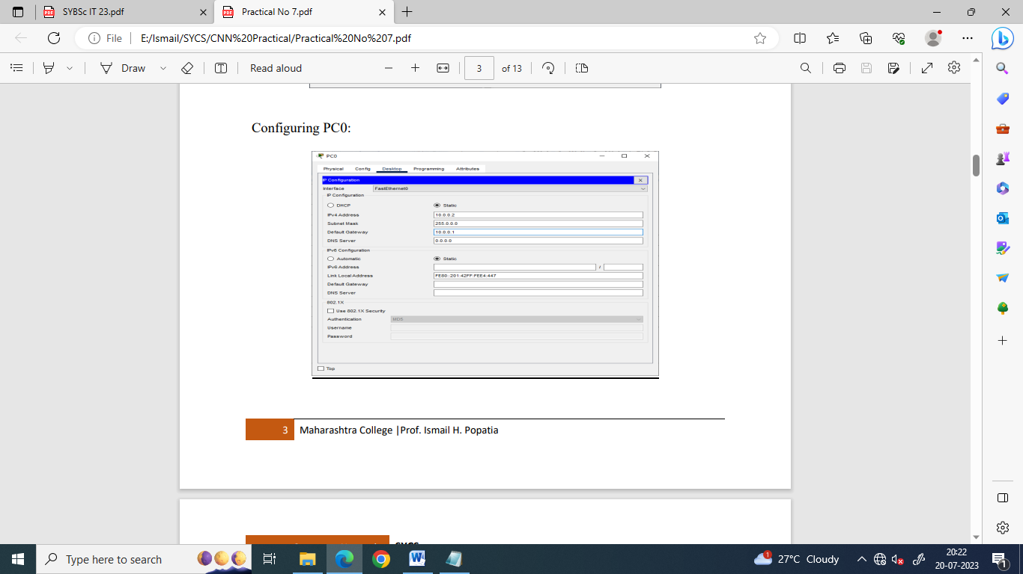

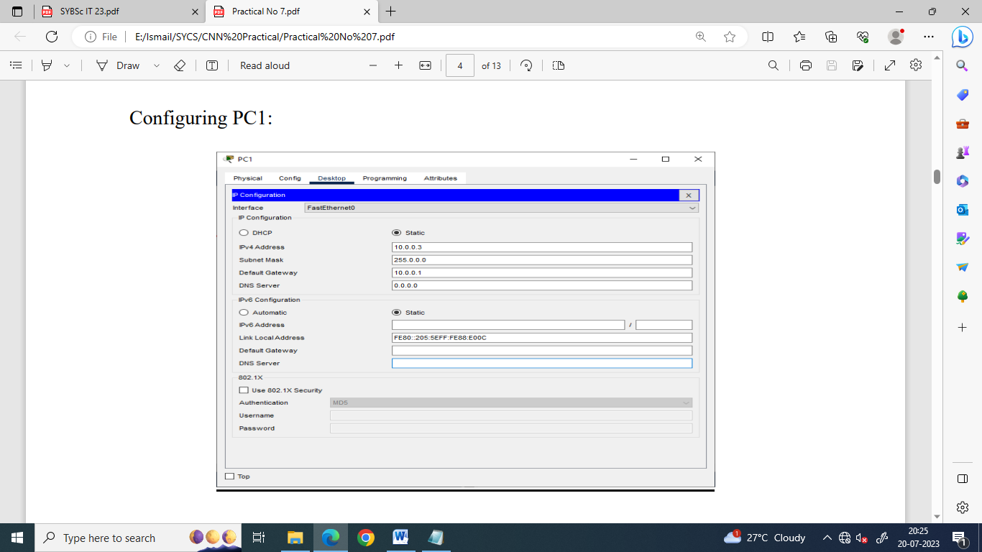

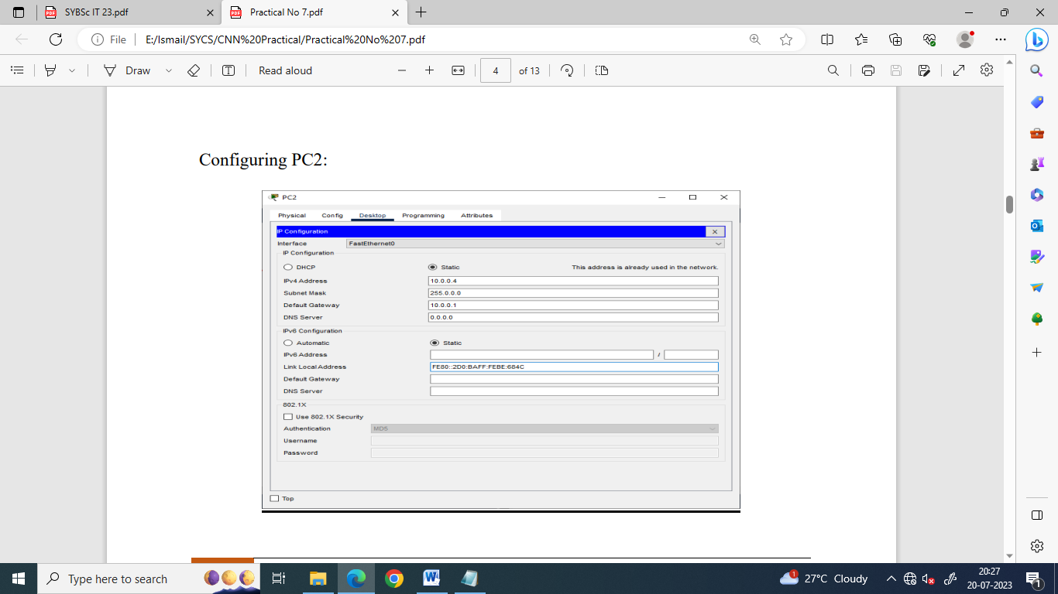

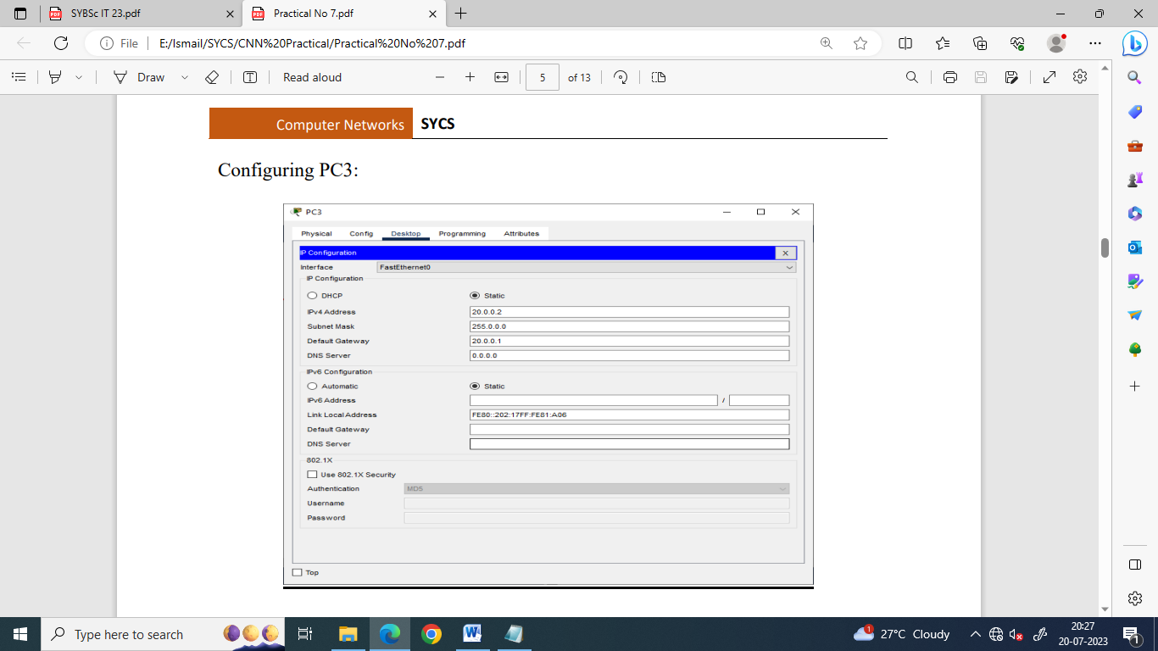

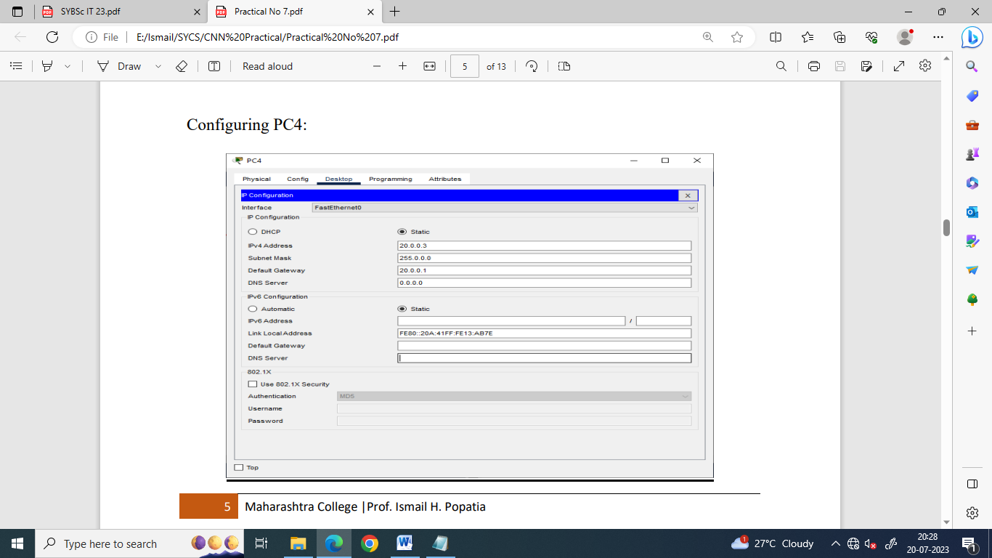

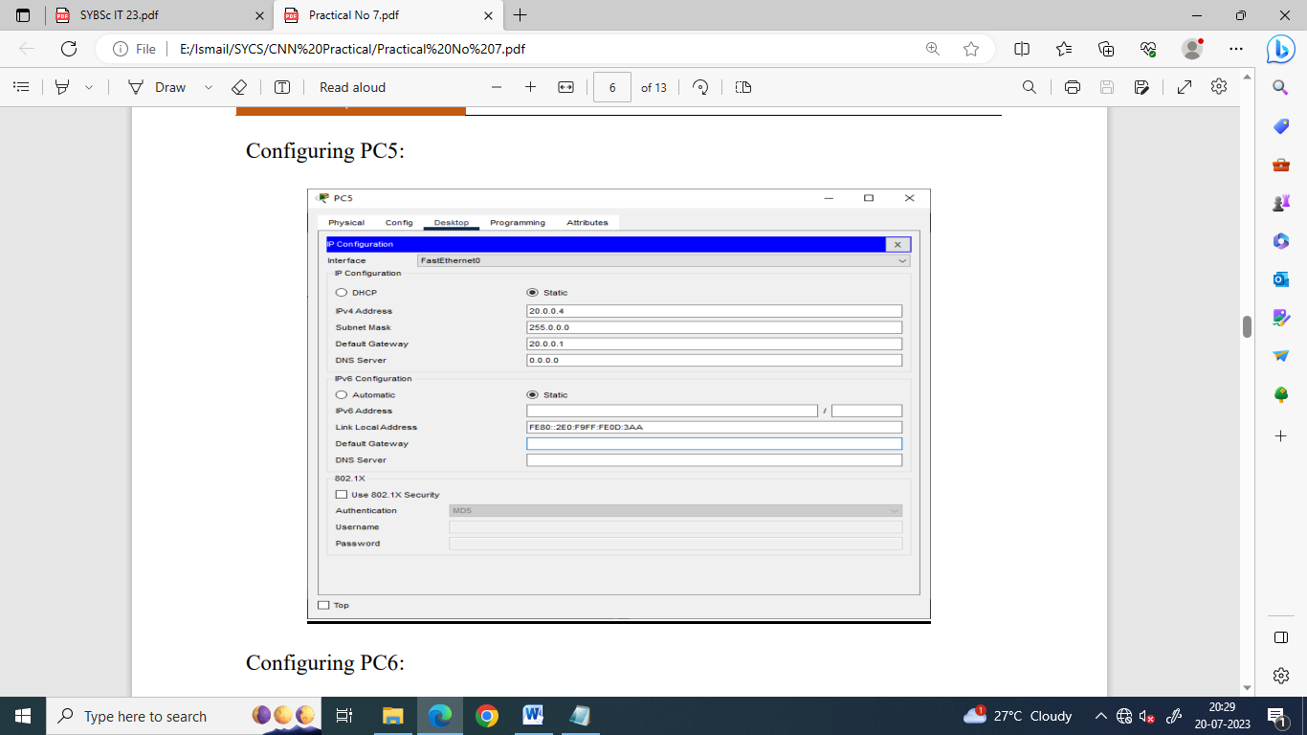

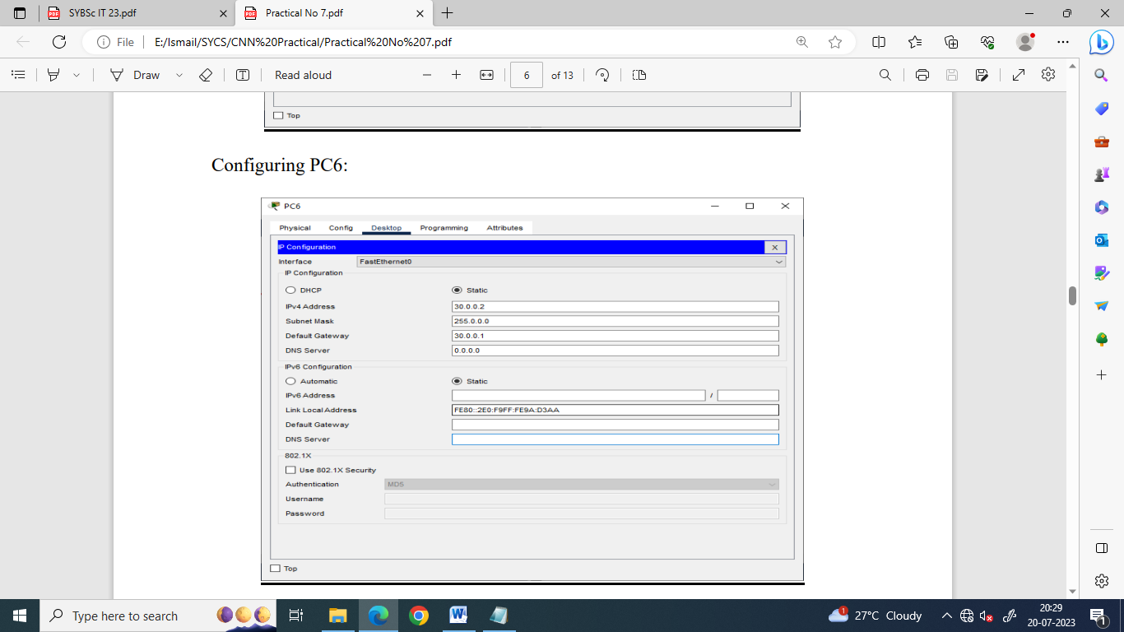

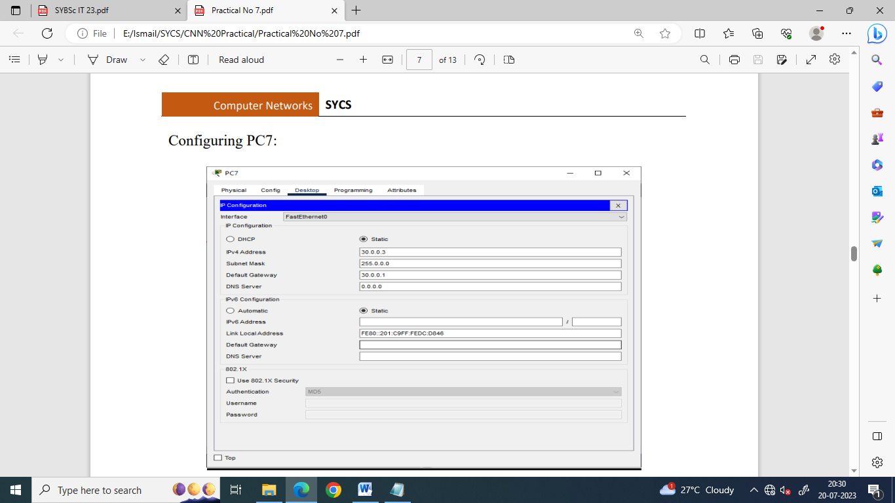

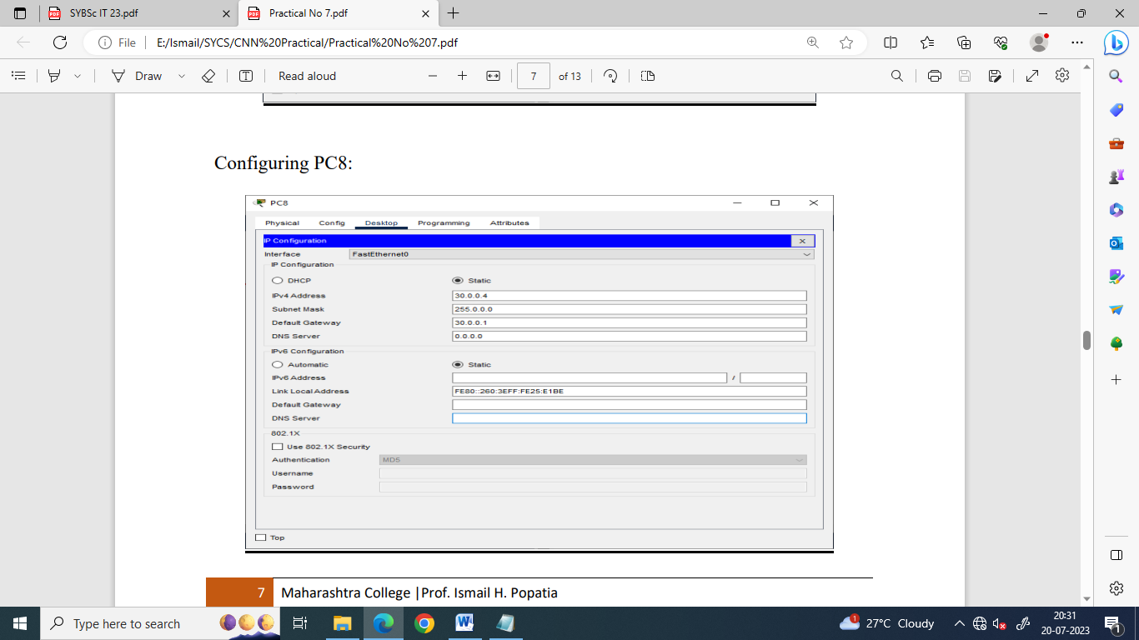

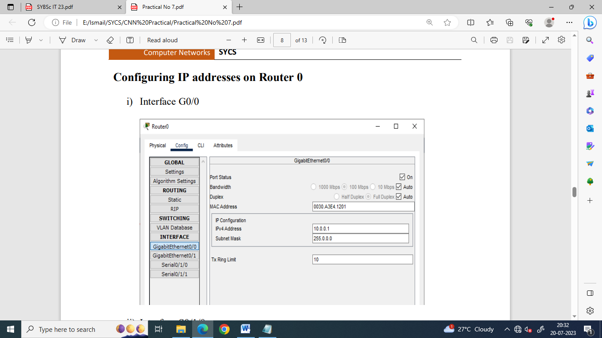

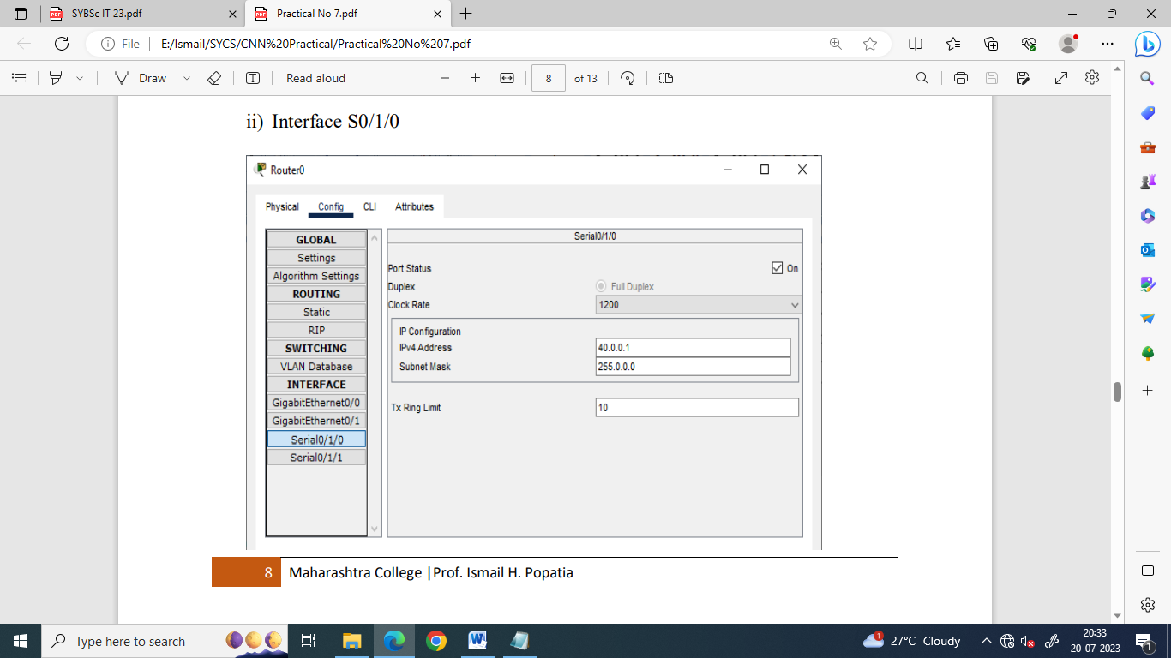

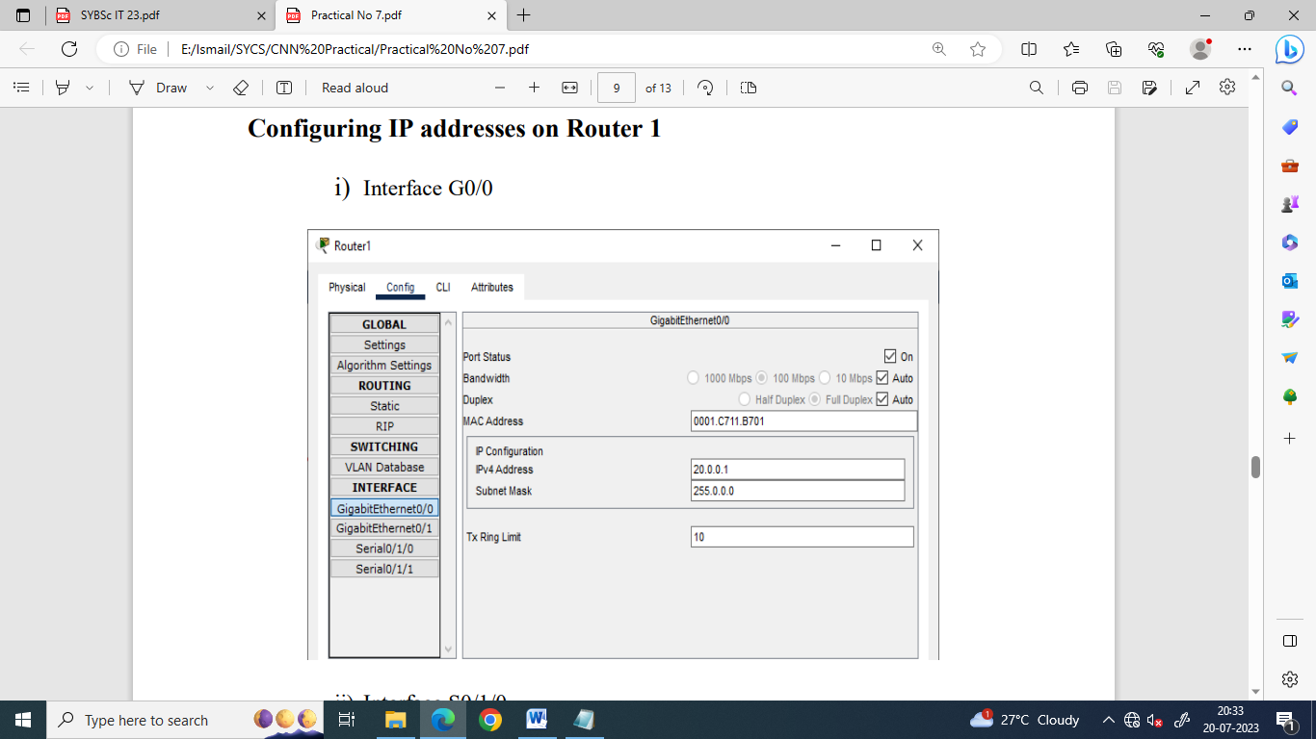

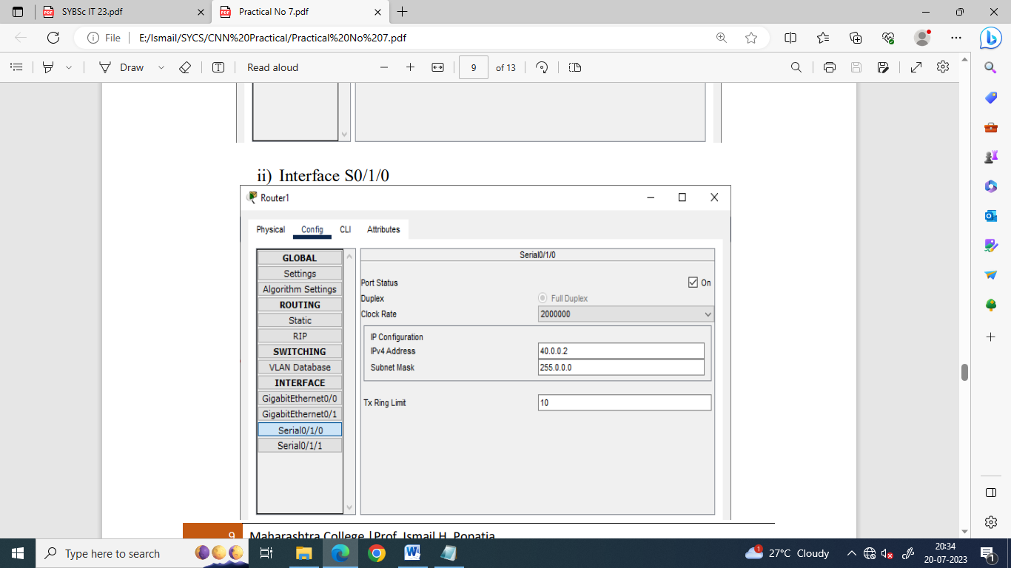

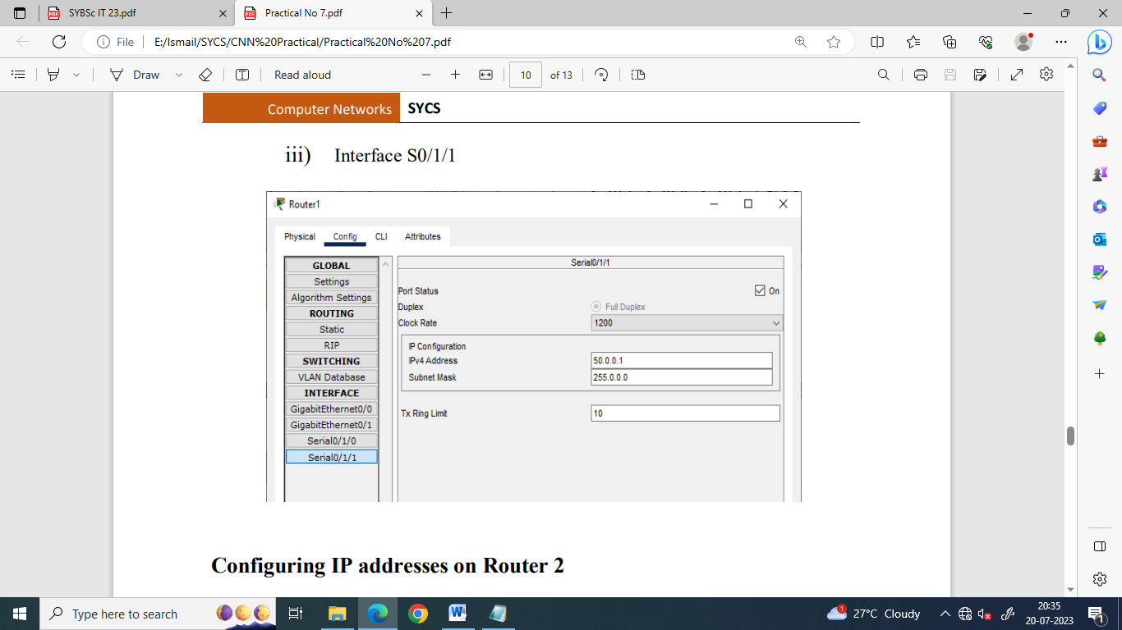

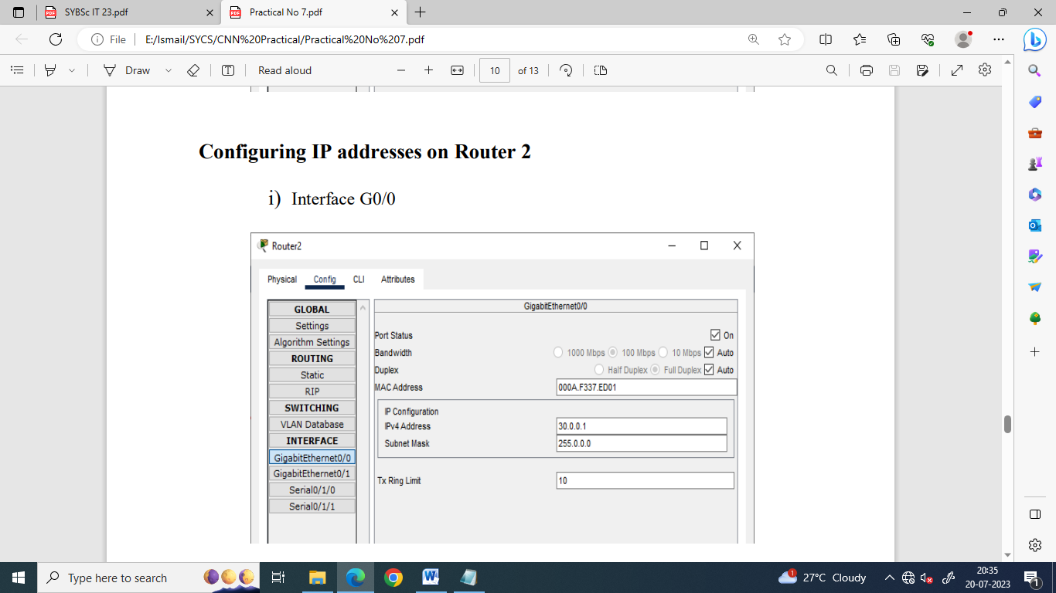

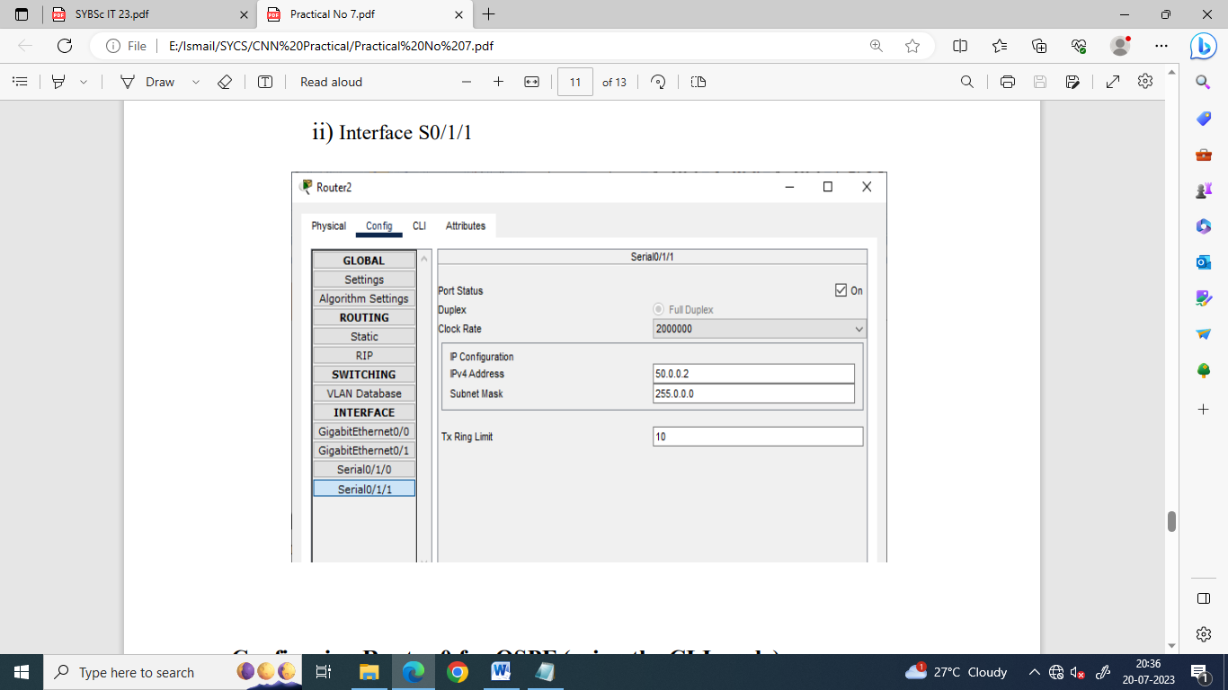

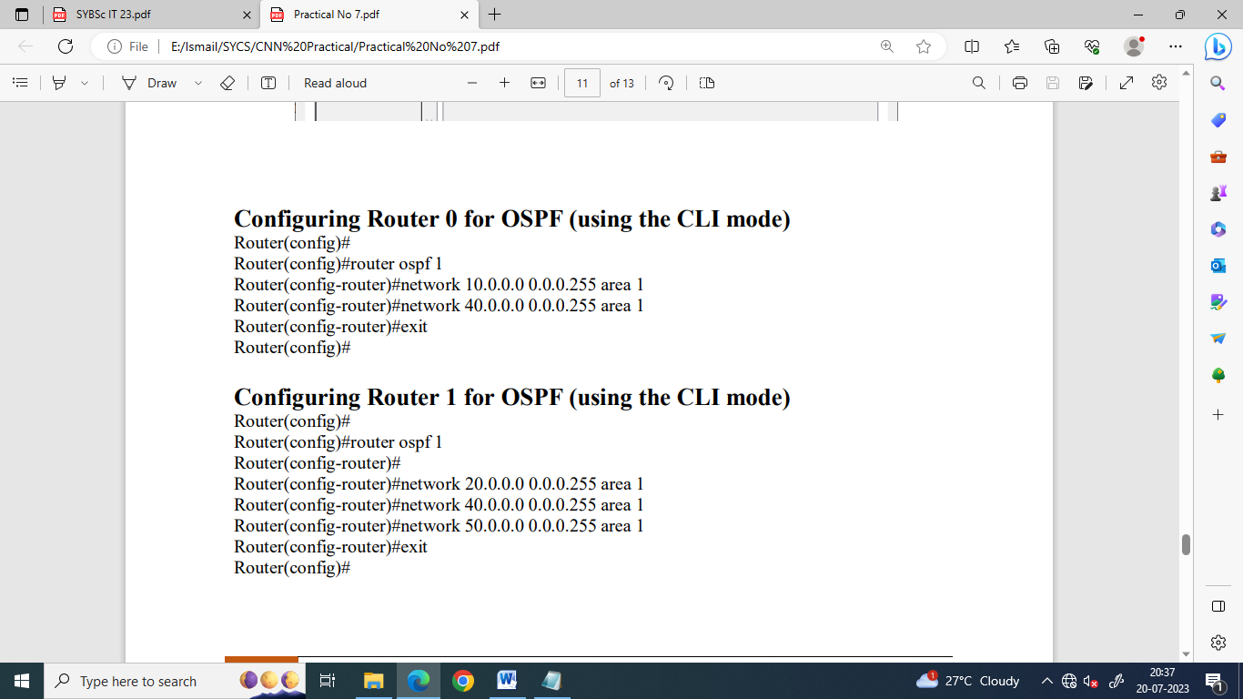

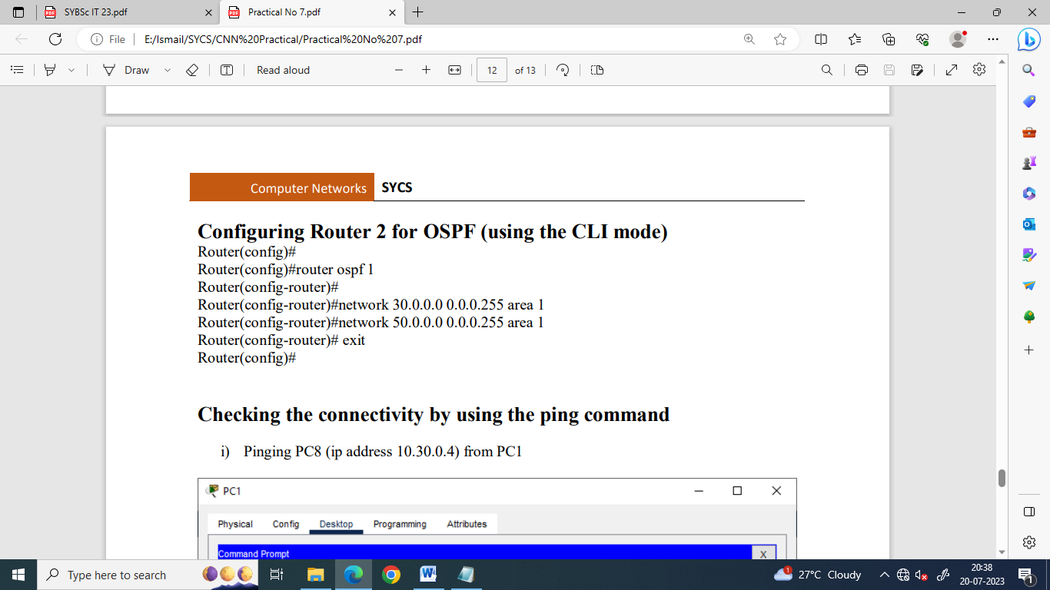

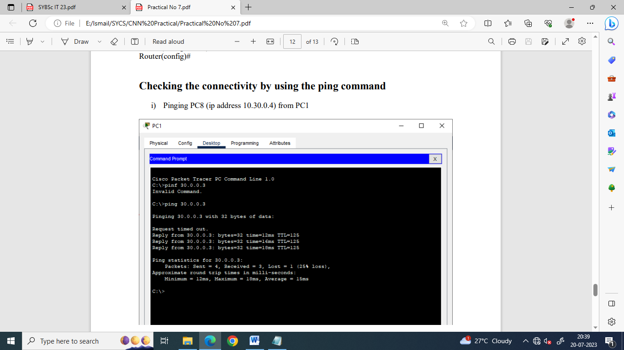

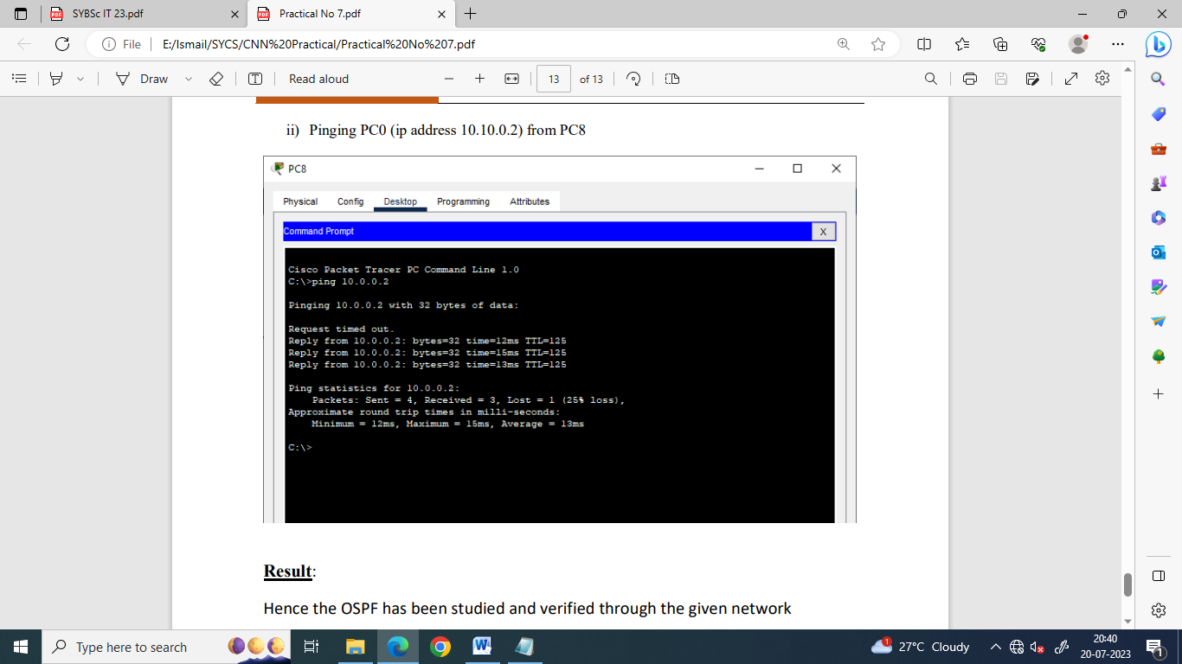

| Scan the following QR-code for the video demostaration of the practical Simple OSPF |  |
| --- | --- |

**Part b) Multi-area OSPF**

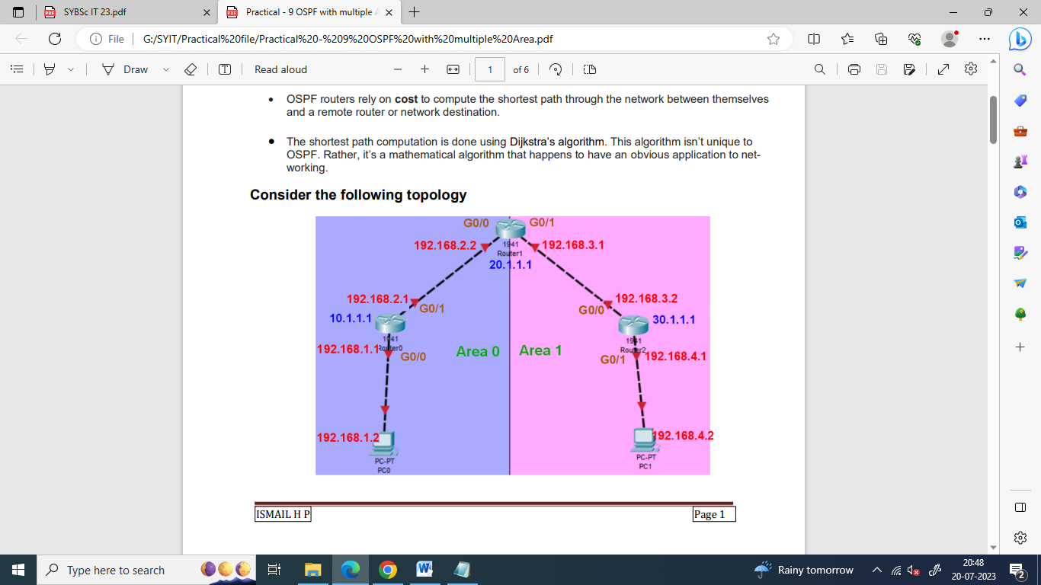

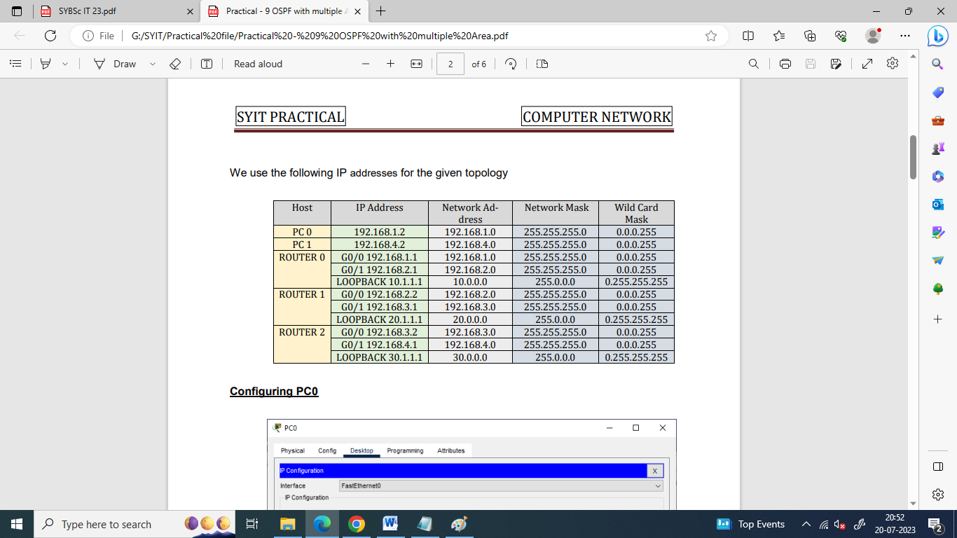

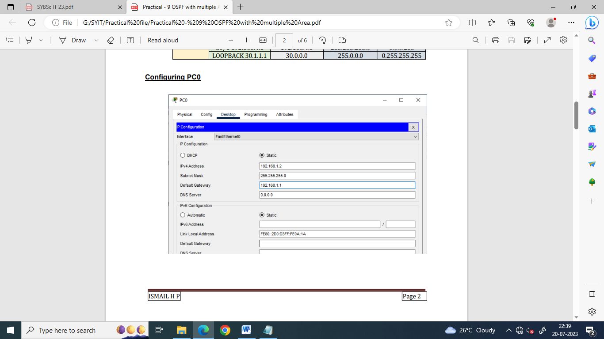

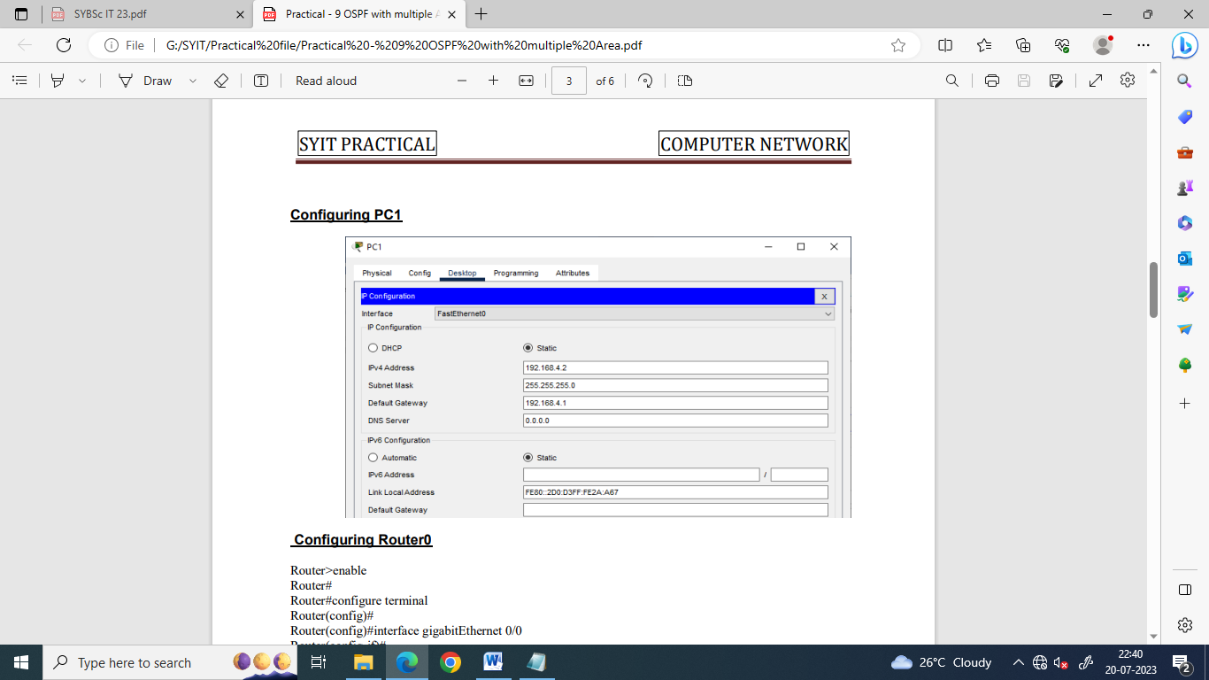

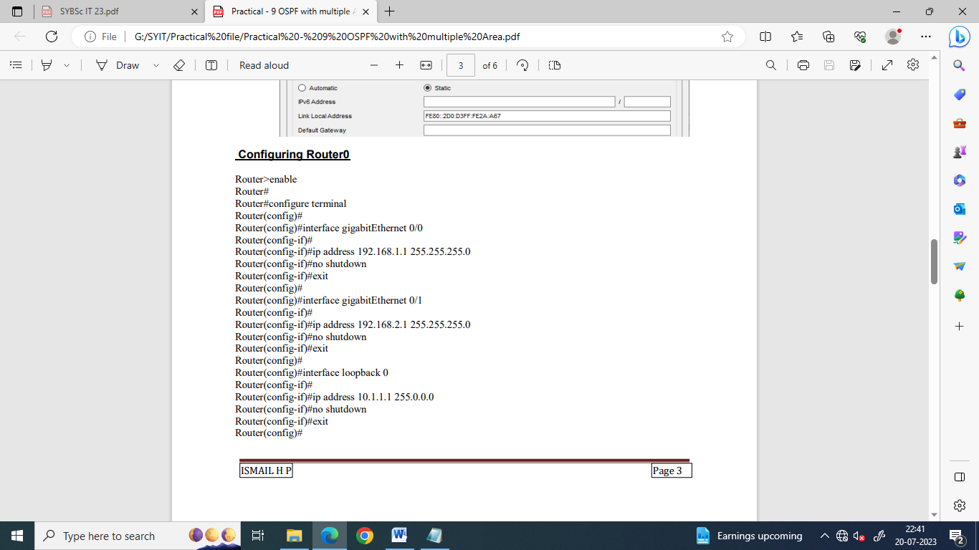



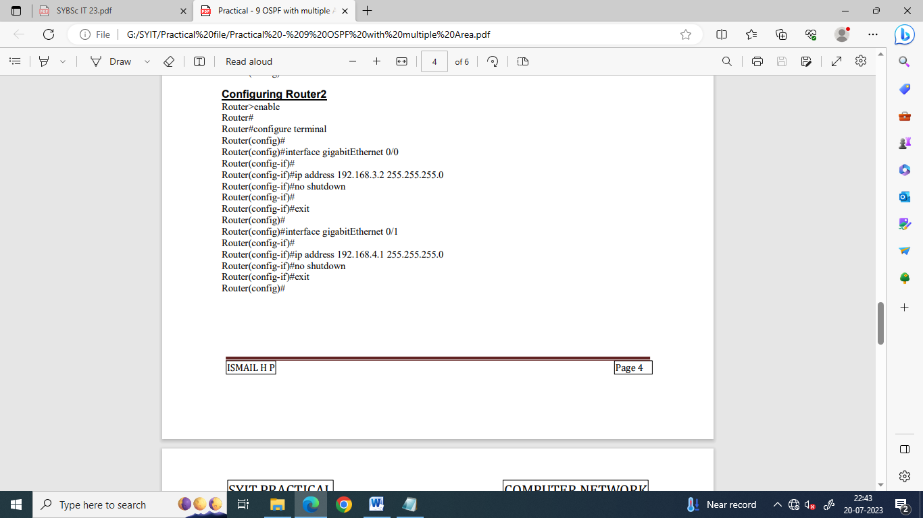

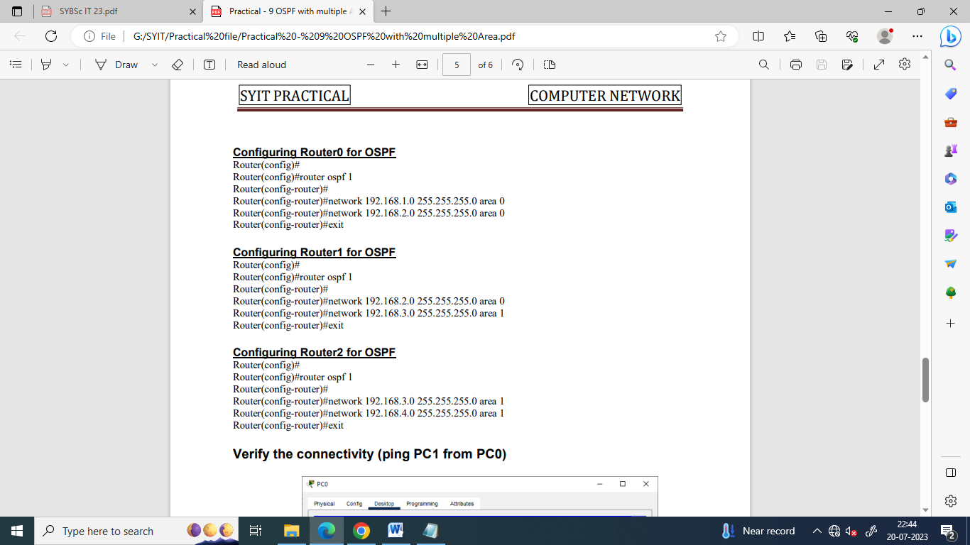

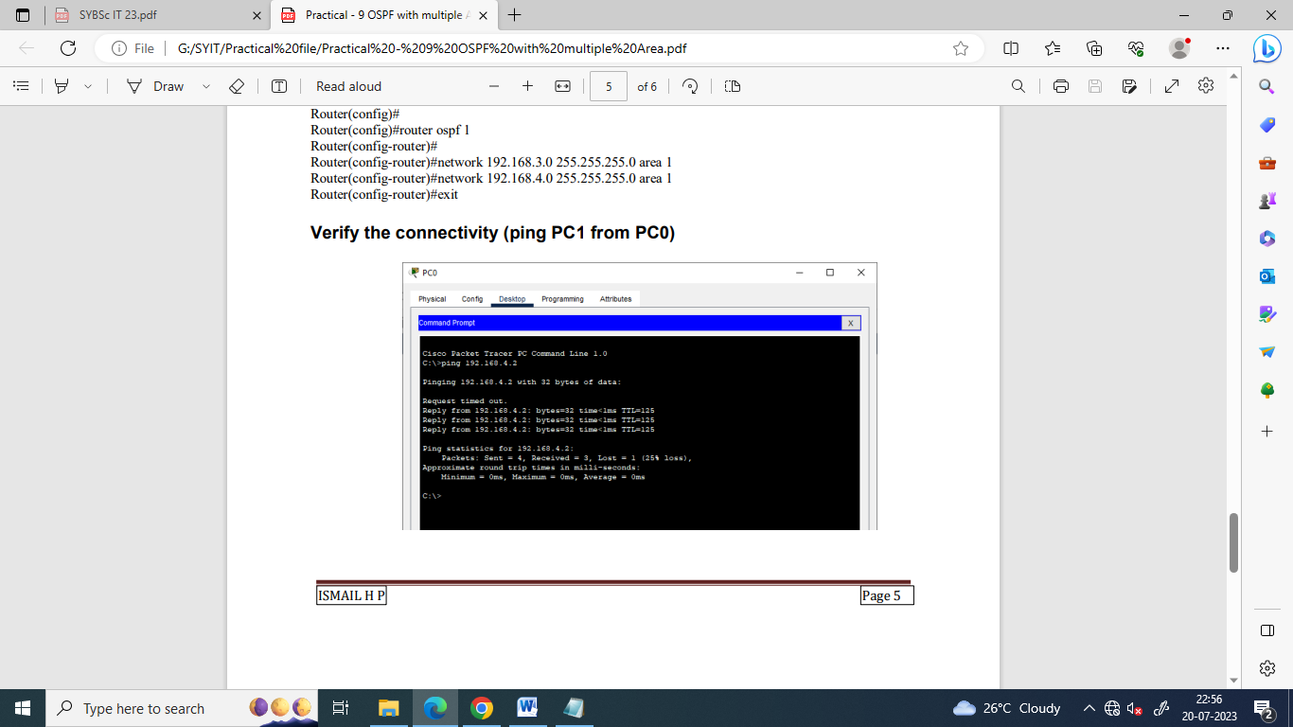

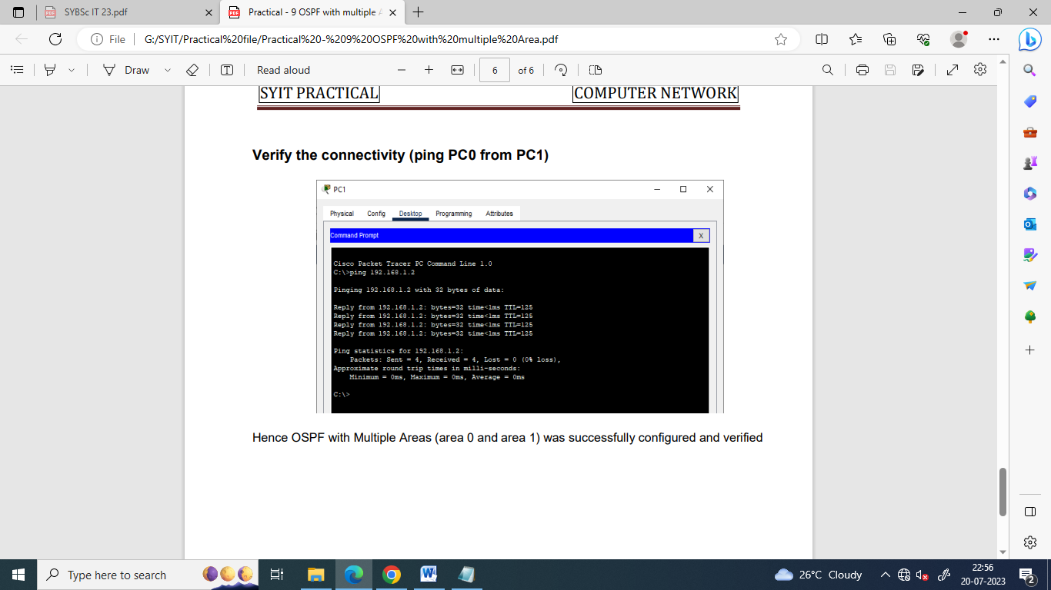

| Scan the following QR-code for the video demostaration of the practical OSPF with Multiple Areas |  |
| --- | --- |